IBM Assignment-1

1.

Registration.html

<html>

    <head>

    </head>

    <body>

    <form method="POST" action="display.html">

        <fieldset><legend>Form</legend>

        <table>

            <tr><td>UserName:</td><td><input type="text" name="username"></td></tr>

            <tr><td>Email:</td><td><input type="email" name="email"></td></tr>

            <tr><td>Password:</td><td><input type="number" name="phone"></td></tr>

            <tr><td></td><td><input type="submit" value="submit"></td></tr>

        </table>

    </fieldset>

    </form>

    </body>

</html>

Display.html

<html>

    <head>

    </head>

    <script>

        var r = window.location.search;

        alert(r);

    </script>

</html>

OUTPUT

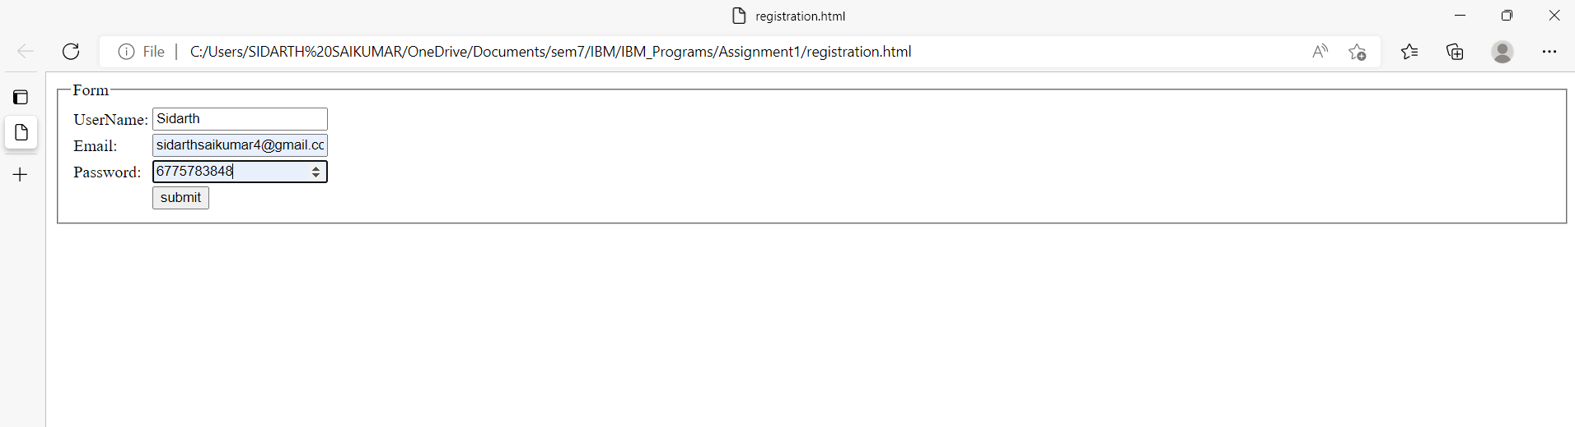

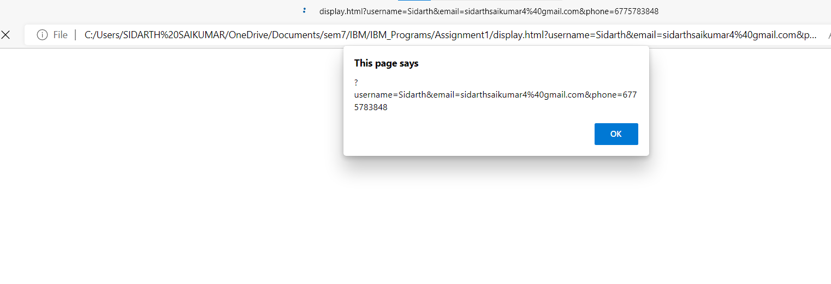

2.

App.py

from flask import Flask, render_template, url_for

from flask_sqlalchemy import SQLAlchemy

from datetime import datetime

app = Flask(__name__)

app.config['SQLALCHEMY_DATABASE_URI'] = 'sqlite:////test.db'

db = SQLAlchemy(app)

class Todo(db.Model):

    id = db.Column(db.Integer, primary_key=True)

    content = db.Column(db.String(200), nullable=False)

    completed = db.Column(db.Integer, default=0)

    date_created = db.Column(db.DateTime, default=datetime.utcnow)

    def __repr__(self):

        return '<Task %r>' % self.id

@app.route('/')

def index():

    return render_template("index.html")

if __name__ == "__main__":

    app.run(debug=True)

index.html

{% extends 'base.html' %}

{% block head %}

{% endblock %}

{% block body %}

<h1>This is just some static content</h1>

{% endblock %}

Base.html

<!DOCTYPE html>

<html lang="en">

<head>

    <meta charset="UTF-8">

    <meta http-equiv="X-UA-Compatible" content="IE=edge">

    <meta name="viewport" content="width=device-width, initial-scale=1.0">

    <link rel="stylesheet" href="{{url_for('static',filename='css/main.css')}}">

    {% block head%}{% endblock %}

</head>

<body>

    {% block body%}{% endblock %}

</body>

</html>

Main.css

body{

    margin:0;

    font-family: sans-serif;

}

OUTPUT